SBSSEOandSERPsPageforWritingandWebsitePresentations
Search-Engine Optimization: How Metadata and Keywords Appear in Search-Engine Results Pages (SERPs)

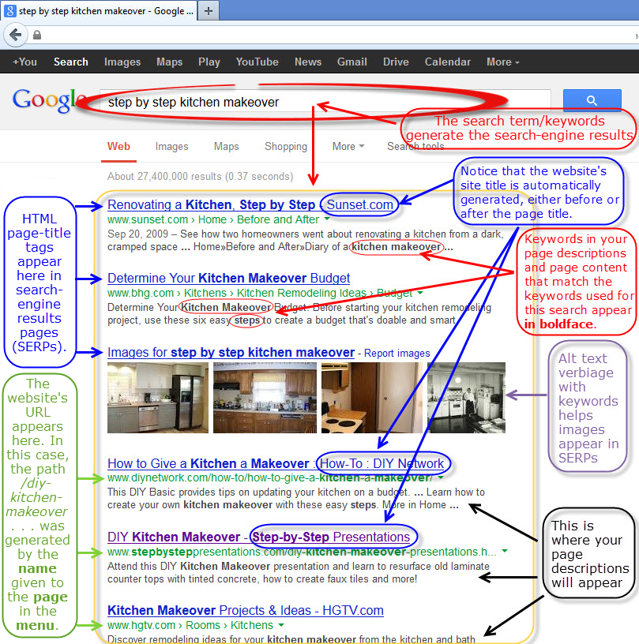

A note about the page description: While it is important to craft a page description with an intentional, actionable, descriptive and keyword-conscious message, realize that there’s no guarantee that it will be pulled up by search engines into SERP snippets. If a search-engine bot sees a better match between the searcher’s keywords/terms and other content on your website, the bot will make that connection, pulling up excerpts that suit the search from your website’s on-page content.
Copyright 2012, Nora Firestone, Step-by-Step Presentations LLC
This content is part of the Step-by-Step “Design, Build and Manage Your Own Website” workshop and is not for republishing, redistribution or use by any other instructor, business coach, website designer or other party without written permission from its copyright holder and subsequent proper attribution. For permission or more information about workshops and services, call (757) 705-7174 or visit www.stepbysteppresentations.com

